Image | 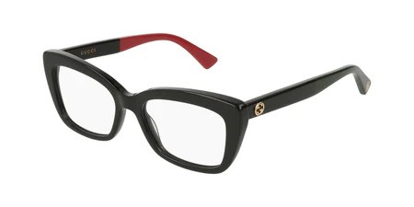
Brand | GUCCI
Model Name | GG 0165ON
Price | RS 2500
PRODUCT DETAILS

